## Nivell 1

Descàrrega els arxius CSV, estudia'ls i dissenya una base de dades amb un esquema d'estrella que contingui, almenys 4 taules de les quals puguis realitzar les següents consultes:

CREATE DATABASE IF NOT EXISTS vendes;  
 USE vendes;  
  
 -- Creamos las tablas   
   
 CREATE TABLE IF NOT EXISTS european_users (  
 id VARCHAR(255) PRIMARY KEY,  
 name VARCHAR(100),  
 surname VARCHAR(100),  
 phone VARCHAR(30),  
 email VARCHAR(50),  
 birth_date VARCHAR(25),  
 country VARCHAR(50),  
 city VARCHAR(50),  
 postal_code VARCHAR(10),  
 address VARCHAR(255)   
 );  
   
 CREATE TABLE IF NOT EXISTS credit_cards (  
 id VARCHAR(255) PRIMARY KEY,  
 user_id VARCHAR(255),   
 iban VARCHAR(255),  
 pan VARCHAR(255),  
 pin VARCHAR(4),  
 cvv VARCHAR(3),  
 track1 VARCHAR(255),  
 track2 VARCHAR(255),  
 expiring_date VARCHAR(25)  
);  
 -- Creamos la tabla company  
 CREATE TABLE IF NOT EXISTS companies (  
 id VARCHAR(255) PRIMARY KEY,  
 name VARCHAR(255),  
 phone VARCHAR(15),  
 email VARCHAR(50),  
 country VARCHAR(50),  
 website VARCHAR(255)  
 );  
  
   
 -- Creamos la tabla transactions  
 CREATE TABLE IF NOT EXISTS transactions (  
 id VARCHAR(255) PRIMARY KEY,  
 card_id VARCHAR(255),   
 business_id VARCHAR(255),  
 date_tx VARCHAR(25),  
 amount DECIMAL(10, 2),  
 declined BOOLEAN,  
 product_ids VARCHAR(255) ,  
 user_id VARCHAR(255) REFERENCES european_users(id),  
 lat VARCHAR(255),  
 longitude VARCHAR(255),  
 FOREIGN KEY (card_id) REFERENCES credit_cards(id),  
 FOREIGN KEY (business_id) REFERENCES companies(id)   
 );

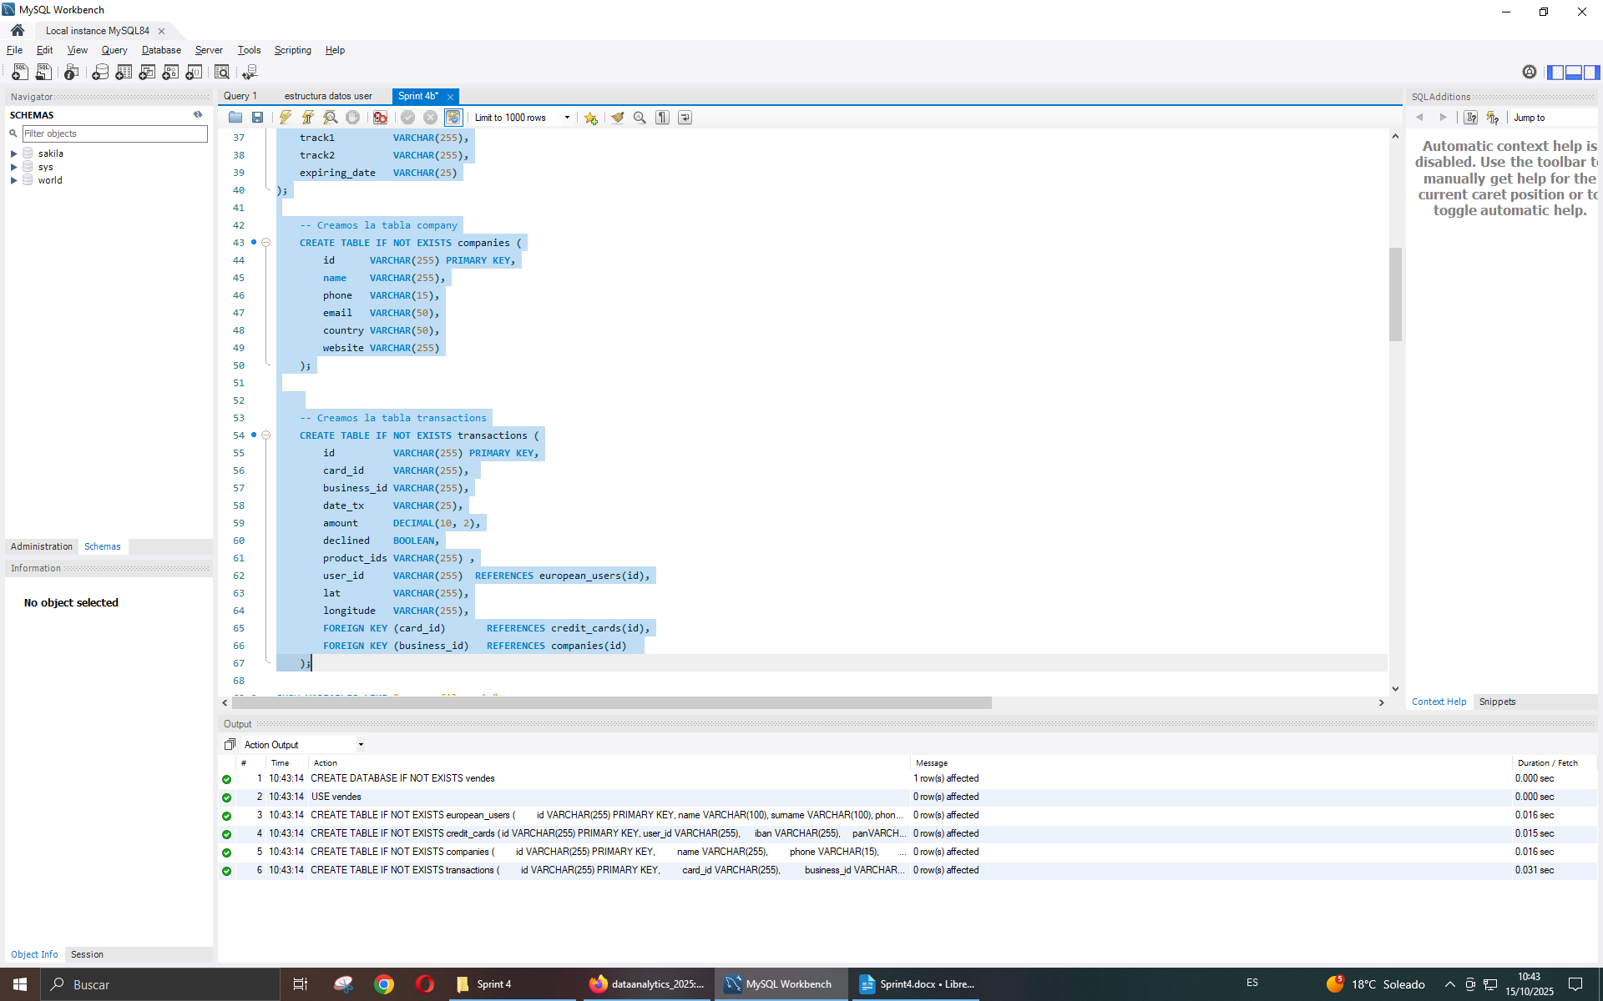

SHOW VARIABLES LIKE "secure_file_priv";  
SELECT @@GLOBAL.secure_file_priv;  
LOAD DATA INFILE "C:/ProgramData/MySQL/MySQL Server 8.0/Uploads/european_users.csv" INTO TABLE european_users  
FIELDS TERMINATED BY ','  
ENCLOSED BY '"'  
LINES TERMINATED BY '\n'  
IGNORE 1 LINES  
(id, name, surname, phone, email, birth_date, country, city, postal_code, address)  
-- SET birth_date = DATE_FORMAT(@birth_date, '%b %d, %Y')  
;   
  
LOAD DATA INFILE "C:/ProgramData/MySQL/MySQL Server 8.0/Uploads/credit_cards.csv" INTO TABLE credit_cards  
FIELDS TERMINATED BY ','  
ENCLOSED BY '"'  
LINES TERMINATED BY '\n'  
IGNORE 1 LINES  
(`id`, `user_id`, `iban`, `pan`, `pin`, `cvv`, `track1`, `track2`, `expiring_date`)  
;   
  
LOAD DATA INFILE "C:/ProgramData/MySQL/MySQL Server 8.0/Uploads/companies.csv" INTO TABLE companies  
FIELDS TERMINATED BY ','  
ENCLOSED BY '"'  
LINES TERMINATED BY '\n'  
IGNORE 1 LINES

(`id`, `name`, `phone`, `email`, `country`, `website`)  
;   
LOAD DATA INFILE "C:/ProgramData/MySQL/MySQL Server 8.0/Uploads/transactions.csv" INTO TABLE transactions  
FIELDS TERMINATED BY ';'  
ENCLOSED BY '"'  
LINES TERMINATED BY '\n'  
IGNORE 1 LINES  
(`id`, `card_id`, `business_id`, `date_tx`, `amount`, `declined`, `product_ids`, `user_id`, `lat`, `longitude`)  
;

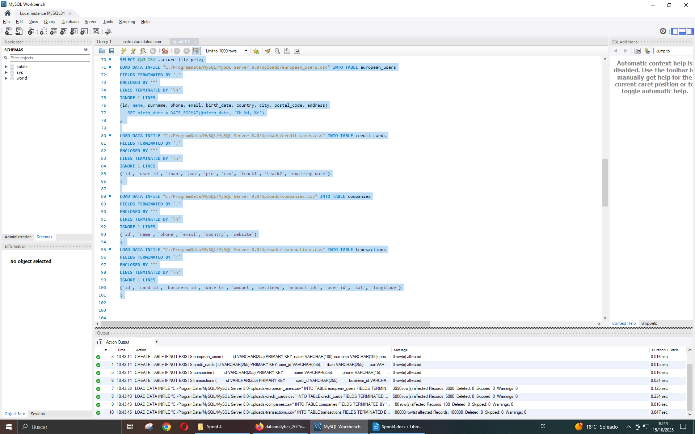

### Exercici 1

Realitza una subconsulta que mostri tots els usuaris amb més de 80 transaccions utilitzant almenys 2 taules.

SELECT u.id, count(u.id) num_tx FROM european_users u  
JOIN transactions t ON user_id = u.id   
GROUP BY u.id   
HAVING count(*) > 80;

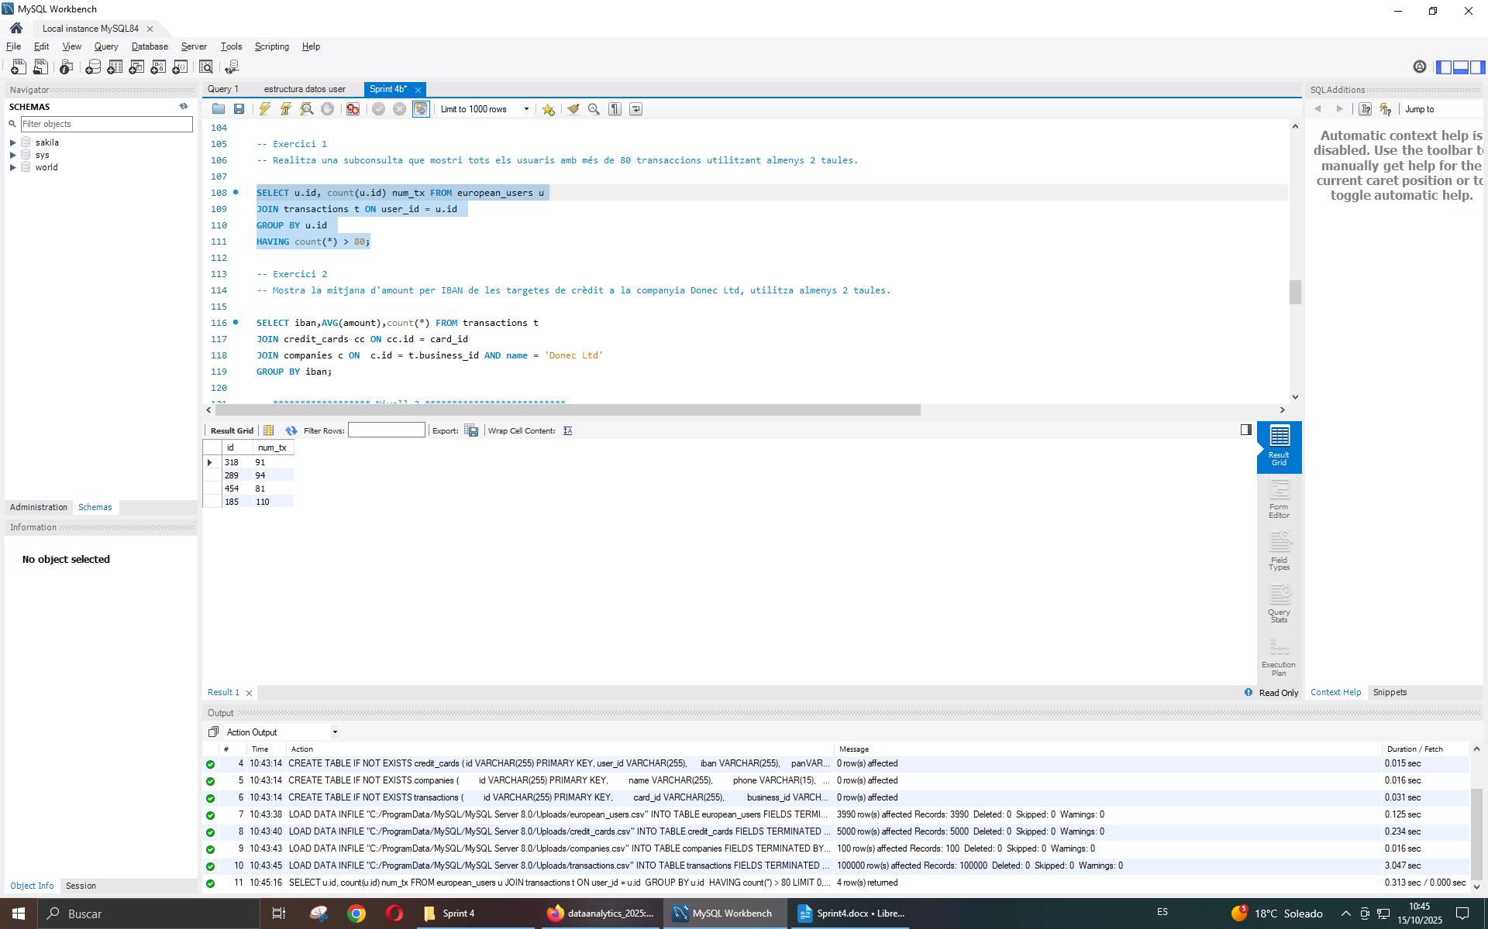

### Exercici 2

Mostra la mitjana d'amount per IBAN de les targetes de crèdit a la companyia Donec Ltd, utilitza almenys 2 taules.

SELECT iban,AVG(amount),count(*) FROM transactions t   
JOIN credit_cards cc ON cc.id = card_id  
JOIN companies c ON c.id = t.business_id AND name = 'Donec Ltd'  
GROUP BY iban;

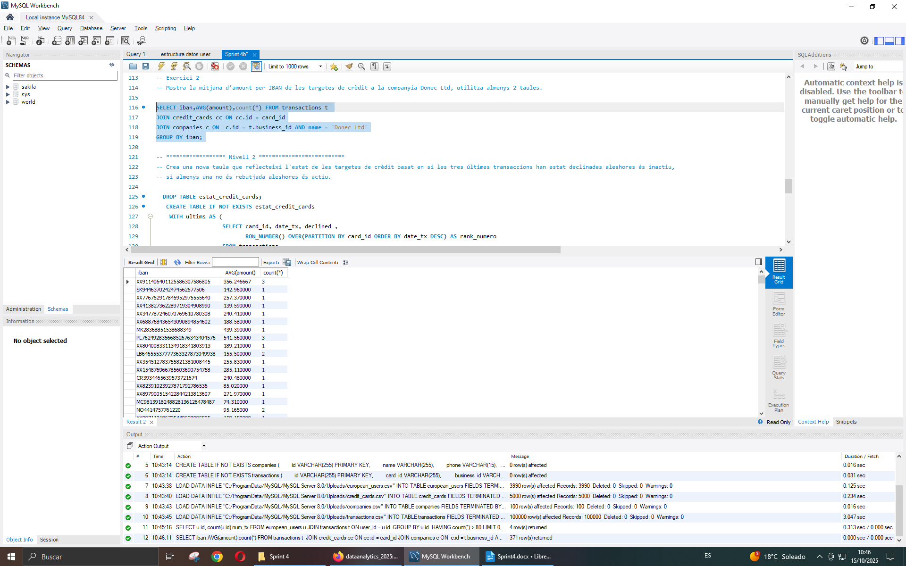

## Nivell 2

Crea una nova taula que reflecteixi l'estat de les targetes de crèdit basat en si les tres últimes transaccions han estat declinades aleshores és inactiu, si almenys una no és rebutjada aleshores és actiu.

CREATE TABLE IF NOT EXISTS estat_credit_cards   
 WITH ultims AS (   
 SELECT card_id, date_tx, declined ,   
 ROW_NUMBER() OVER(PARTITION BY card_id ORDER BY date_tx DESC) AS rank_numero   
 FROM transactions  
 WHERE declined=1  
 order by card_id,rank_numero  
 )   
 SELECT card_id , 0 AS estat FROM ultims ul WHERE EXISTS (SELECT card_id WHERE rank_numero =3 AND card_id = ul.card_id)   
 UNION  
 SELECT DISTINCT(card_id), 1 AS estat FROM transactions WHERE card_id NOT IN ( SELECT card_id FROM ultims ul WHERE EXISTS (SELECT card_id WHERE rank_numero =3 AND card_id = ul.card_id) )  
 ;

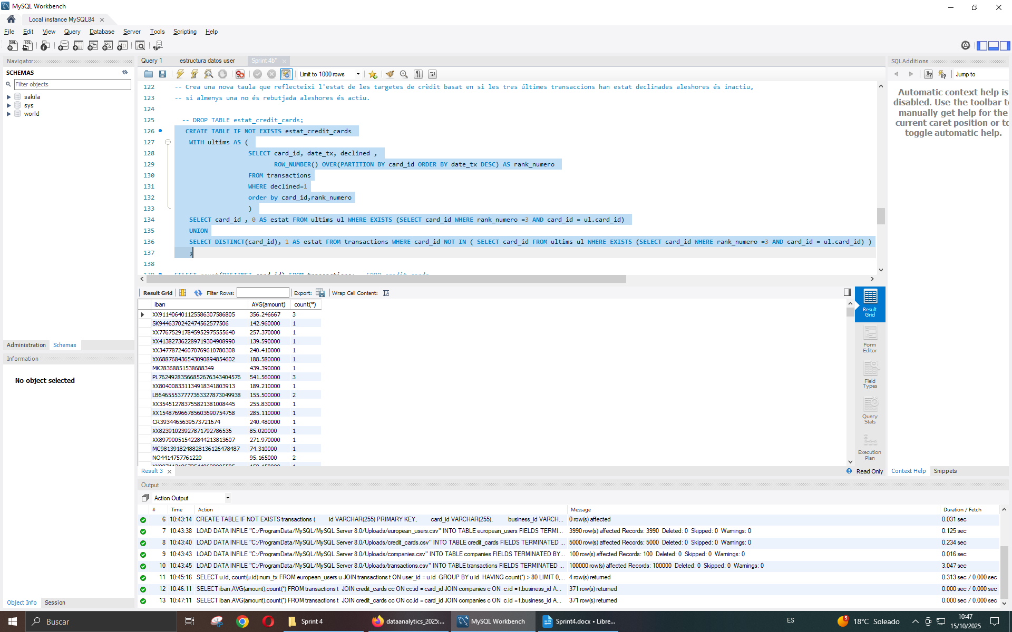

Partint d’aquesta taula respon:

### Exercici 1

Quantes targetes estan actives?

SELECT COUNT(*) FROM estat_credit_cards WHERE estat=1;

## 

## Nivell 3

Crea una taula amb la qual puguem unir les dades del nou arxiu products.csv amb la base de dades creada, tenint en compte que des de transaction tens product_ids. Genera la següent consulta:

CREATE TABLE IF NOT EXISTS products (  
 id VARCHAR(255) PRIMARY KEY REFERENCES transactions(product_id),  
 product_name VARCHAR(255),  
 price VARCHAR(255),  
 colour VARCHAR(50),  
 weight VARCHAR(50),  
 warehouse_id VARCHAR(255)  
 );   
  
LOAD DATA INFILE "C:/ProgramData/MySQL/MySQL Server 8.0/Uploads/products.csv" INTO TABLE products  
FIELDS TERMINATED BY ','  
ENCLOSED BY '"'  
LINES TERMINATED BY '\n'  
IGNORE 1 LINES  
(`id`,`product_name`,`price`,`colour`,`weight`,`warehouse_id`)  
;

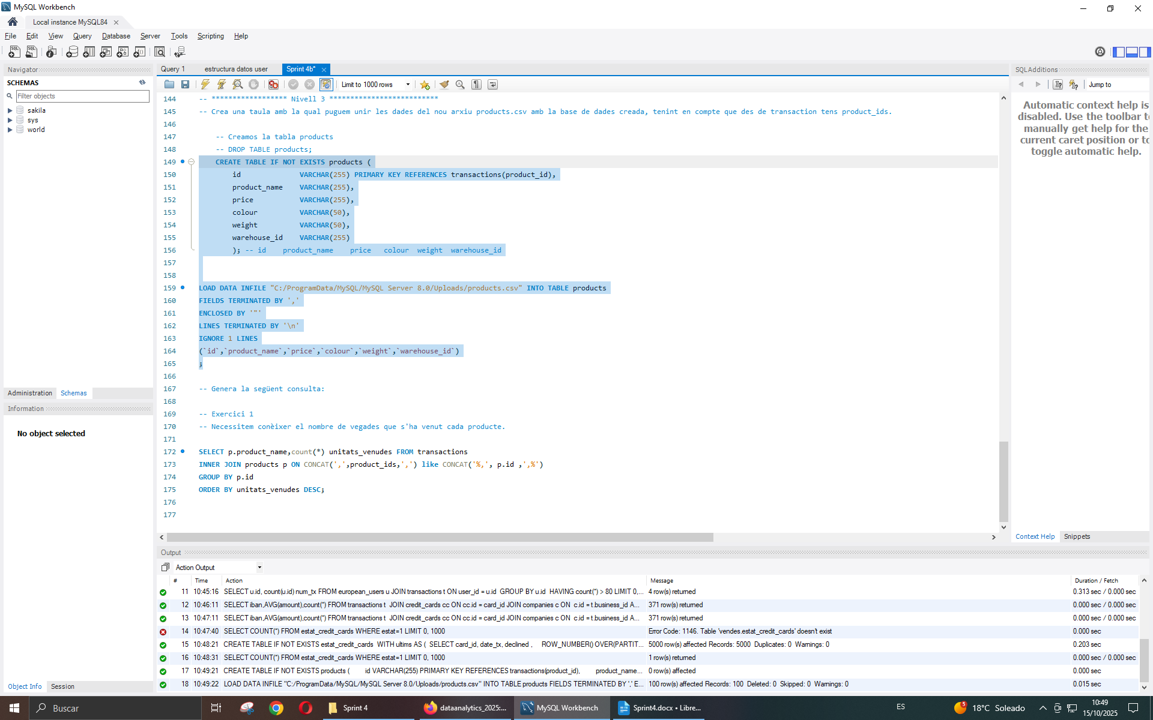

### Exercici 1

Necessitem conèixer el nombre de vegades que s'ha venut cada producte.

SELECT p.product_name,count(*) unitats_venudes FROM transactions  
INNER JOIN products p ON CONCAT(',',product_ids,',') like CONCAT('%,', p.id ,',%')  
GROUP BY p.id  
ORDER BY unitats_venudes DESC;

